Week 6 – NPCs

**Section 1 – Importing character and animations**

1. Open the Epic Games Launcher
2. Navigate to Marketplace and search for Animation Starter Pack

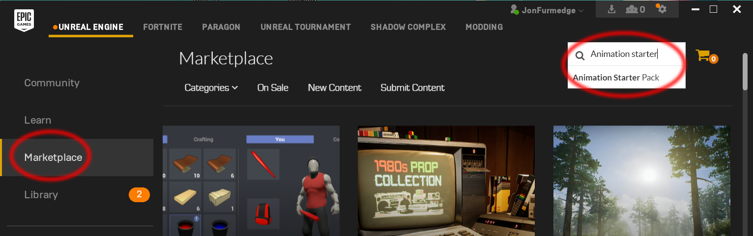

1. Scroll down and click the “Add to Project” button

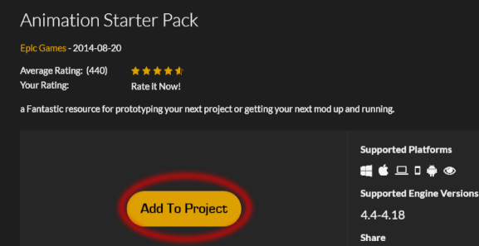

1. Select the correct project then “Add to Project”
2. You should now see a new folder called AnimStarterPack

**Section 2 – Creating the NPC class & blueprint**

1. Create a new C++ class called NPCBase deriving from Character
2. Compile visual studio
3. Create a new blueprint class from NPCBase called NPC_BP
4. Select the Mesh Component then:
   1. Set its Z position to – 90 (so it lines up with capsule)
   2. Set Anim Class to UE4ASP_HeroTPP_AnimBlueprint
   3. Set Skeletal Mesh to SK_Mannequin

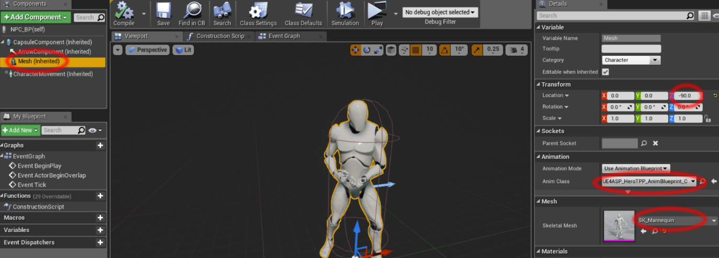

1. Drag an instance of your newly created blueprint into the scene, it should stand there and play an idle animation.

**Section 3 – Shooting the NPC**

Before we can shoot the NPC we are going to need to add some properties to our WeaponBase class.

1. Give it a Damage and DamageType property

/** Projectile class to spawn */

UPROPERTY(EditDefaultsOnly, Category = Gameplay)

TSubclassOf<class UDamageType> DamageType;

UPROPERTY(EditAnywhere, BlueprintReadWrite, Category = Gameplay)

float Damage;

We are also going to need to create a new DamageType for bullet damage

1. Create a new blueprint class and derive it from DamageType
2. Call it DamageType_Bullet
3. Leave its settings as default for now.

Open up your rifle blueprint and assign a damage value and set its DamageType.

Currently the linetrace will only collide with objects that block on the visibility channel, by default pawns do not so we will need to change this:

1. Open project settings; Edit-Project Settings..
2. Select Engine->Collision, then expand “Preset”, double click on Pawn.

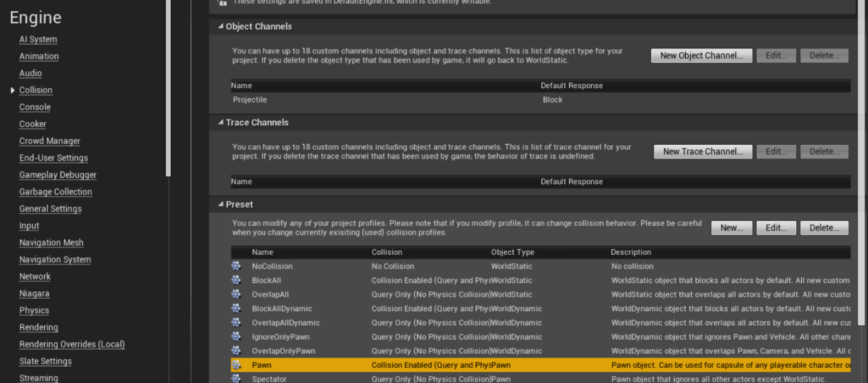

1. Change “Visibility” to Block and press Accept.

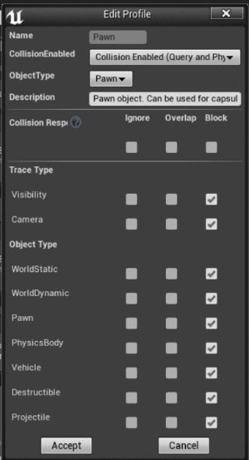

The linetrace when you shoot should now hit the NPC.

**Section 4 – Damaging the NPC**

*I am going to keep this as simple as possible, if you want to expand on this with for example an interface or health component then feel free.*

In your BaseWeapon.cpp find where the linetrace has successfully hit an actor. Insert this code:

AActor* hitActor = hit.GetActor();

UGameplayStatics::ApplyDamage(hitActor, Damage, MyOwner->GetInstigatorController(), MyOwner,DamageType);

Now open up your NPC_BP and in the event graph create the following:

*Don’t forget to select Hit_React_1 as the “New Anim to Play”.*

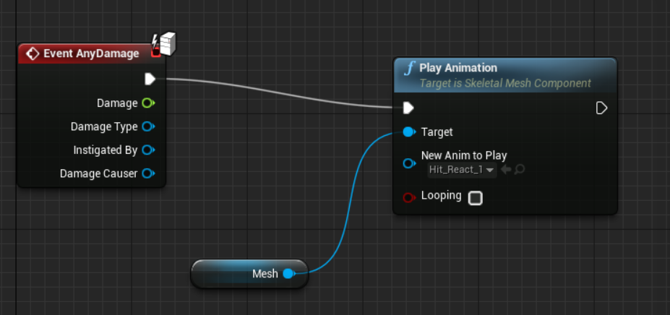

When you shoot the NPC it should now play a hit animation.

**Challenges ()**

1. Add health to your NPC
   1. Easy – Add float variables in blueprint
   2. Medium – Create a new base class in C++ that *yourproject*Character and NPCBase derive from, health is handled here.
   3. Hard – Create a new type of component in C++ for managing health and attach to NPC.
2. Play death animation when NPC dies
3. Look into the animation graph, ideally we want to be able to set states, i.e hit, idle, running, dead and play set animations.

<https://docs.unrealengine.com/en-US/Engine/Animation/AnimBlueprints/AnimGraph>